Chemistry 115 Name
Dr. Cary Willard
Quiz 2A (20 points) February 10, 2009

All work must be shown to receive credit.

- (5 points) Use dimensional analysis to determine the number of dimes that are equal to 69 quarters.

$$?dimes=69 quarters×\frac{5 nickels}{1 quarter}×\frac{1 dime}{2 nickels}=172 dimes$$

- (5 points) A barrel holds 36.2 gallons of kerosene. How many liters of kerosene does the barrel hold? (1 gallon = 4 quarts)

$$?L=42.7 gal×\frac{4 qt}{1 gal}×\frac{1 L}{1.06 qt}=161 L$$

- (5 points) My dog ran 3.22 km this morning. How many mm did my dog run?

$$?mm=3.22 km×\frac{1000 m}{1 km}×\frac{1000 mm}{1 m}=3.22×{10}^{6} mm$$

- (5 points) The ruler below is calibrated to measure centimeters. How long is the line in cm? 6.29 cm

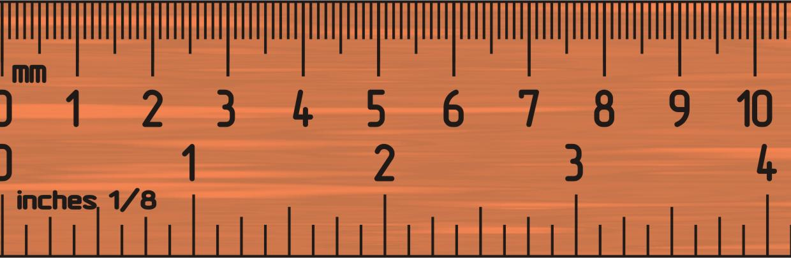
Chemistry 115 Name
Dr. Cary Willard
Quiz 2B (20 points) February 10, 2009

All work must be shown to receive credit.

- (5 points) Use dimensional analysis to determine the number of dimes that are equal to 53 quarters.

$$?dimes=53 quarters×\frac{5 nickels}{1 quarter}×\frac{1 dime}{2 nickels}=132 dimes$$

- (5 points) A barrel holds 42.7 gallons of kerosene. How many liters of kerosene does the barrel hold? (1 gallon = 4 quarts)

$$?L=42.7 gal×\frac{4 qt}{1 gal}×\frac{1 L}{1.06 qt}=161 L$$

- (5 points) My dog ran 4.01 km this morning. How many mm did my dog run?

$$?mm=4.01 km×\frac{1000 m}{1 km}×\frac{1000 mm}{1 m}=4.01×{10}^{6} mm$$

- (5 points) The ruler below is calibrated to measure centimeters. How long is the line in cm? 4.73 cm

